Question 03

Lab 08

Question 01: Can a friend function be used to overload an operator that modifies the invoking object?

**Yes, a friend function can be used to overload an operator like +=, but it must take the left-hand operand by reference (&). Because friend functions are not members of the class.**

Question 2: Is it possible to overload an operator using a friend function if one operand is a primitive data type?

**Yes, it can be used to overload operators, when one of them is a primitive type.**

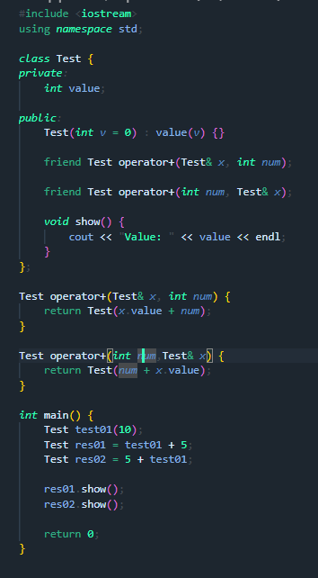

Question 3: Can a friend function access private/protected members without using an object?

**No, a friend needs an object to access private or protected members.**

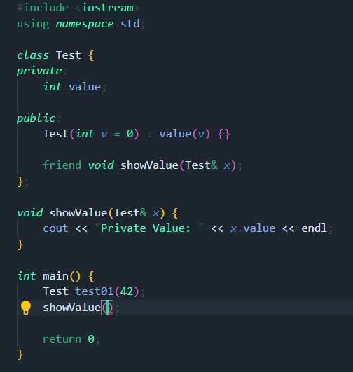

**Without Object its given error**

